E-LEARNING PLATFORM - PROJECT REPORT

# 1. INTRODUCTION

## 1.1 Project Overview

E-Learning Platform is a robust, feature-rich web application developed using the MERN stack (MongoDB, Express.js, React.js, Node.js), designed to modernize and streamline the experience of online education for both learners and educators. With a focus on accessibility, interactivity, and data security, the platform caters to a broad spectrum of users — from individual instructors and academic institutions to corporate trainers and self-paced learners — who seek a reliable and flexible way to create, manage, and participate in online courses.

In today’s fast-paced, knowledge-driven economy, online learning platforms have become essential tools for delivering education, professional development, and training. However, many existing platforms either limit customization, require advanced technical knowledge for course setup, or lack integrated systems for progress tracking, certification, and secure payment handling. The E-Learning Platform addresses this gap by offering an intuitive drag-and-drop course builder and seamless content management capabilities — enabling instructors to design interactive, visually appealing, and highly personalized courses without writing a single line of code.

The platform supports a wide range of educational content types, including but not limited to video lectures, PDF documents, quizzes, and assignments. Course creators have full control over structuring their content into modules, enabling flexible learning paths, setting up prerequisites, and tracking student progress with real-time analytics. The platform also allows branding customization, giving instructors and institutions the ability to align courses with their unique identity through customizable themes, logos, and certificates.

What sets the E-Learning Platform apart is its comprehensive support for secure transactions, role-based access control, and automated certification issuance. The system integrates smoothly with third-party services such as Stripe for payment processing, Cloudinary for media storage, and Nodemailer for automated email notifications — enabling an end-to-end digital learning experience from enrollment to certification.

Beyond course delivery, the platform also empowers educators and administrators with rich reporting and analytics features, including visual dashboards that present student progress, course completion rates, revenue insights, and engagement trends. These insights are essential for making data-driven decisions on course improvements, learner support, and content updates — especially for universities, training agencies, and independent instructors aiming for scalable and sustainable growth in the e-learning space.

## 1.2 Purpose

The primary objective of the E-Learning Platform is to offer an intuitive, reliable, and scalable digital learning environment where educators can create and deliver courses, students can engage with content at their own pace, and administrators can efficiently manage users, payments, and performance — all without requiring deep technical expertise. This project was initiated to address the growing demand for flexible, accessible, and secure online education solutions across various industries and educational sectors.

For instance, an independent instructor aiming to teach specialized courses online often faces challenges in designing professional-looking lessons, securely handling payments, issuing certificates, and tracking student progress. Traditional solutions either require hiring developers or relying on fragmented tools for each task, making the process expensive, time-consuming, and error-prone. The E-Learning Platform solves this problem by offering an all-in-one system where instructors can easily create structured courses, embed rich media content, and automate the certification process upon course completion.

Similarly, a corporate training department tasked with onboarding new employees may struggle to maintain uniformity in content delivery and tracking of employee progress across different departments and regions. The E-Learning Platform enables companies to design comprehensive training modules, track real-time completion data, issue compliance certificates, and generate detailed reports — ensuring both efficiency and accountability.

Even for students, traditional learning platforms can create friction with scattered resources, limited interactivity, and lack of clear feedback on their progress. E-Learning Platform empowers learners with user-friendly navigation, bookmarking, discussion forums, and real-time progress tracking, making the learning journey smoother, more interactive, and more motivating.

The platform’s purpose extends far beyond simply hosting educational content. By integrating secure payment gateways, role-based access management, certification systems, and real-time analytics into a single, cohesive solution, the E-Learning Platform helps instructors focus on teaching, students focus on learning, and administrators focus on scaling — ultimately creating a connected ecosystem where knowledge flows without barriers.

# 2. IDEATION PHASE

## 2.1 Problem Statement

In today’s increasingly digital world, the ability to access quality education anytime and anywhere has become more of a necessity than a luxury. Whether for academic courses, professional training, or self-improvement, learners and instructors alike are relying heavily on online platforms to bridge the knowledge gap. However, the majority of existing e-learning solutions fall short when it comes to offering a user-centric, secure, and fully integrated learning ecosystem.

For instructors and educational institutions, creating and managing online courses often becomes a tedious and fragmented process. Many platforms limit customization, lack intuitive content organization tools, or require a steep technical learning curve — which discourages subject-matter experts from embracing digital teaching. Additionally, the absence of automated systems for progress tracking, student assessment, and certification makes it difficult for educators to scale their offerings and maintain academic rigor.

For students, the learning experience is often disrupted by inconsistent user interfaces, unclear navigation paths, and disconnected content delivery. In the absence of real-time progress tracking and interactive community features, learners tend to lose motivation, resulting in low course completion rates and limited engagement.

Administrators, too, face unique hurdles. Managing user accounts, moderating content, handling secure payments, and monitoring system performance across a growing user base are essential but complex tasks. Most platforms require separate plugins, manual interventions, or even third-party services to accomplish what should ideally be part of a unified system.

Security is another major concern for both course providers and learners. Educational platforms often involve sensitive personal information, including payment data, academic progress records, and certification history. Without built-in security features like encrypted transactions, secure authentication protocols, and role-based access control, users are left exposed to data breaches and fraud.

Given this context, there is a clear and urgent need for an e-learning platform that can bridge these gaps through an integrated, user-friendly, and secure solution. The ideal system should empower instructors to focus on content creation, allow students to learn at their own pace with confidence, and equip administrators with tools for seamless operation — all while maintaining robust data privacy, real-time reporting, and customizable workflows.

The E-Learning Platform was developed specifically to address these challenges, providing a single, streamlined ecosystem that enhances the teaching, learning, and administration experience for modern digital education.

Problem Statement Table:

|  |  |  |  |  |
| --- | --- | --- | --- | --- |
| I am (Customer) | I’m trying to | But | Because | Which makes me feel |
| Instructor | Design an engaging course | The tools lack flexibility | They require coding knowledge | Frustrated and limited |
| Student | Track progress and earn certificates | The platform is confusing | Features are scattered | Lost and demotivated |
| Admin | Monitor system health and payments | No unified dashboards | Monitoring tools are costly | Inefficient and overwhelmed |

## 2.2 Empathy Map

## 

## 2.3 Brainstorming

## Step-1: Team Gathering, Collaboration and Select the Problem Statement and Brainstorm, Idea Listing and Grouping

## 

## 

## Step-2: Idea Prioritization

Our team conducted a structured brainstorming session to improve the usability, security, and flexibility of the E-Learning Platform — a comprehensive tool designed for creating, managing, and delivering interactive online courses. The session followed a three-step design thinking process: defining the problem, generating ideas, and prioritizing solutions.

We began by framing our core problem statement as:

**“How might we make it easier, more secure, and more engaging for instructors to create and for students to access online courses through the E-Learning Platform?”**

With this guiding question, each of the four team members proposed three unique ideas based on their own experiences and research, resulting in a total of 12 key suggestions. From these contributions, four major themes naturally emerged during discussion:

* **Course Design & Usability:**Ideas focused on simplifying course creation through a drag-and-drop module builder, real-time previews, and intuitive layouts to make the process as straightforward as possible for non-technical instructors.
* **Data & Security:**Since educational platforms deal with sensitive user information and financial transactions, ensuring strong security was identified as a top priority. Suggestions included JWT-based authentication, Stripe payment gateway integration, SSL encryption, and secured student data storage.
* **Integration & Analytics:**To improve administrative efficiency and enrich the learning experience, the team discussed integrating third-party services such as Cloudinary for media storage, Stripe for secure payments, and automated certification systems, along with real-time analytics for both instructors and students.
* **Customization & Branding:**Ideas were shared around giving instructors control over course appearance through customizable themes, certificates, and email templates to enhance brand identity and personalization.

After the brainstorming session, the team grouped similar concepts and assessed them based on their feasibility, technical complexity, and expected user impact. High-impact and high-feasibility features were selected as immediate development goals:

* Drag-and-drop course builder
* Stripe payment gateway integration
* Automated certificate generation

Meanwhile, more advanced or resource-intensive ideas — such as AI-driven course recommendations, multi-language support, and blockchain-secured certification — were acknowledged as valuable but deprioritized for future iterations, once the core platform had stabilized.

This brainstorming exercise helped the team crystallize both short-term objectives and long-term ambitions for the E-Learning Platform. It established a user-centered development roadmap that balances modern learning demands with technical scalability and system security.

# 3. REQUIREMENT ANALYSIS

## 3.1 Customer Journey map

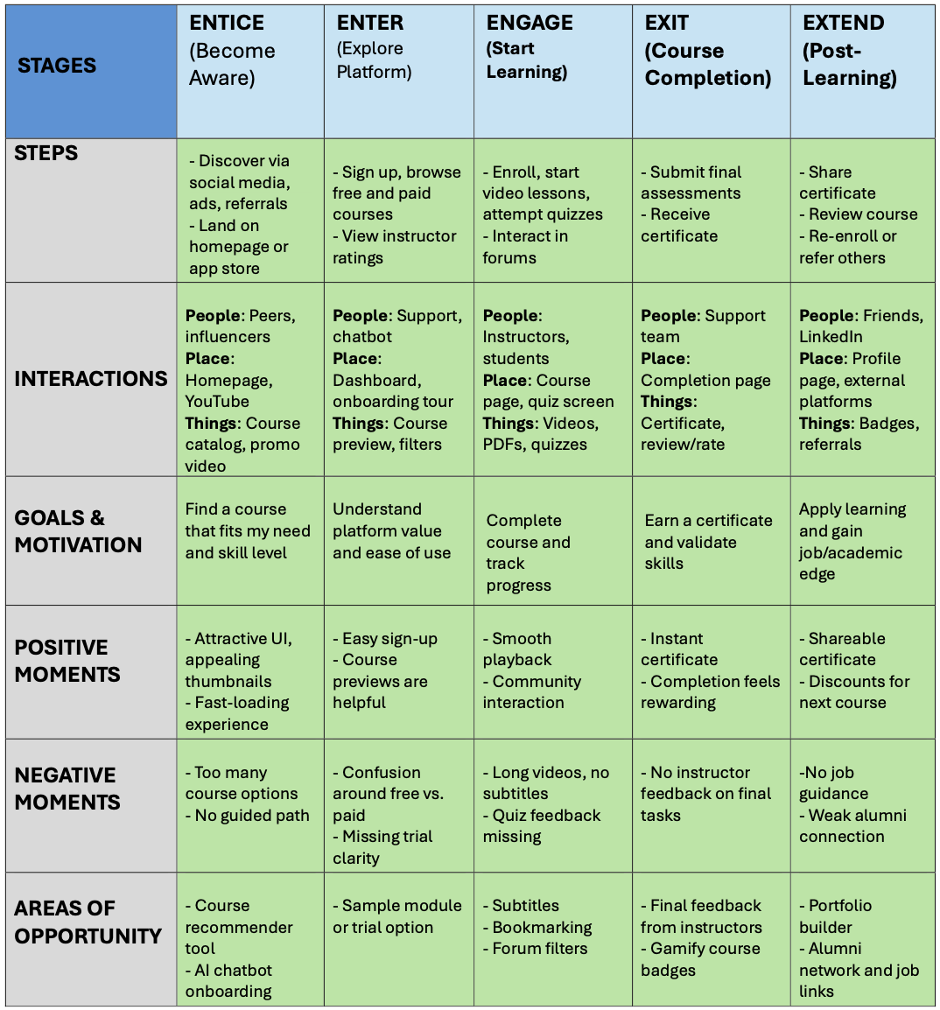

## 3.2 Solution Requirement

### Functional Requirements Table:

|  |  |  |
| --- | --- | --- |
| **FR No.** | **Functional Requirement (Epic)** | **Sub Requirement (Story / Sub-Task)** |
| 1 | **User Registration** | Registration via Email  Registration via Google  Registration via Facebook |
| 2 | **User Authentication** | Email/Password Login  JWT Token Authentication  Password Reset |
| 3 | **Course Management** | Course Creation (Instructor)  Course Enrollment (Student)  Course Progress Tracking (Student)  Interactive Quiz Integration |
| 4 | **Payment Integration** | Stripe Payment Gateway for Course Purchases  Payment History Tracking  Refund Process |
| 5 | **Certifications** | Generate PDF Certificates upon Completion  Automatic Certification Trigger on Course Completion |
| 6 | **Discussion Forums** | Course-Specific Forums for Discussions  Real-time Messaging between Students and Instructors |
| 7 | **Admin Dashboard** | User Role Management (Admin, Instructor, Student)  Content Moderation Tools  System Health Monitoring |
| 8 | **Analytics & Reporting** | Student Performance Analytics  Revenue Reports for Instructors  Course Popularity Metrics |
| 9 | **Content Management** | Upload Videos, PDFs, and Quizzes  Drag-and-Drop Module Builder for Instructors |

### Non-Functional Requirements Table

|  |  |  |
| --- | --- | --- |
| **FR No.** | **Non-Functional Requirement** | **Description** |
| 1 | **Usability** | User-friendly UI for all user roles (Instructors, Students, Admins)  Responsive design for mobile and desktop views |
| 2 | **Security** | SSL encryption for secure communication  JWT for secure authentication  Payment data encryption (Stripe API) |
| 3 | **Reliability** | System should ensure no data loss during course progress tracking  High availability for real-time interaction features (Discussions, Messaging) |
| 4 | **Performance** | Fast page load times, optimized for high traffic  Efficient course and video streaming without buffering |
| 5 | **Scalability** | Handle increasing number of users and course content  Support growing user base with horizontal scaling |
| 6 | **Availability** | 99.9% uptime, minimal downtime during maintenance |
| 7 | **Compliance** | Ensure compliance with data protection laws (e.g., GDPR)  Secure payment processing and user data handling |

## 3.3 Data Flow Diagram

## 

## 3.4 Technology Stack

Technical Requirements

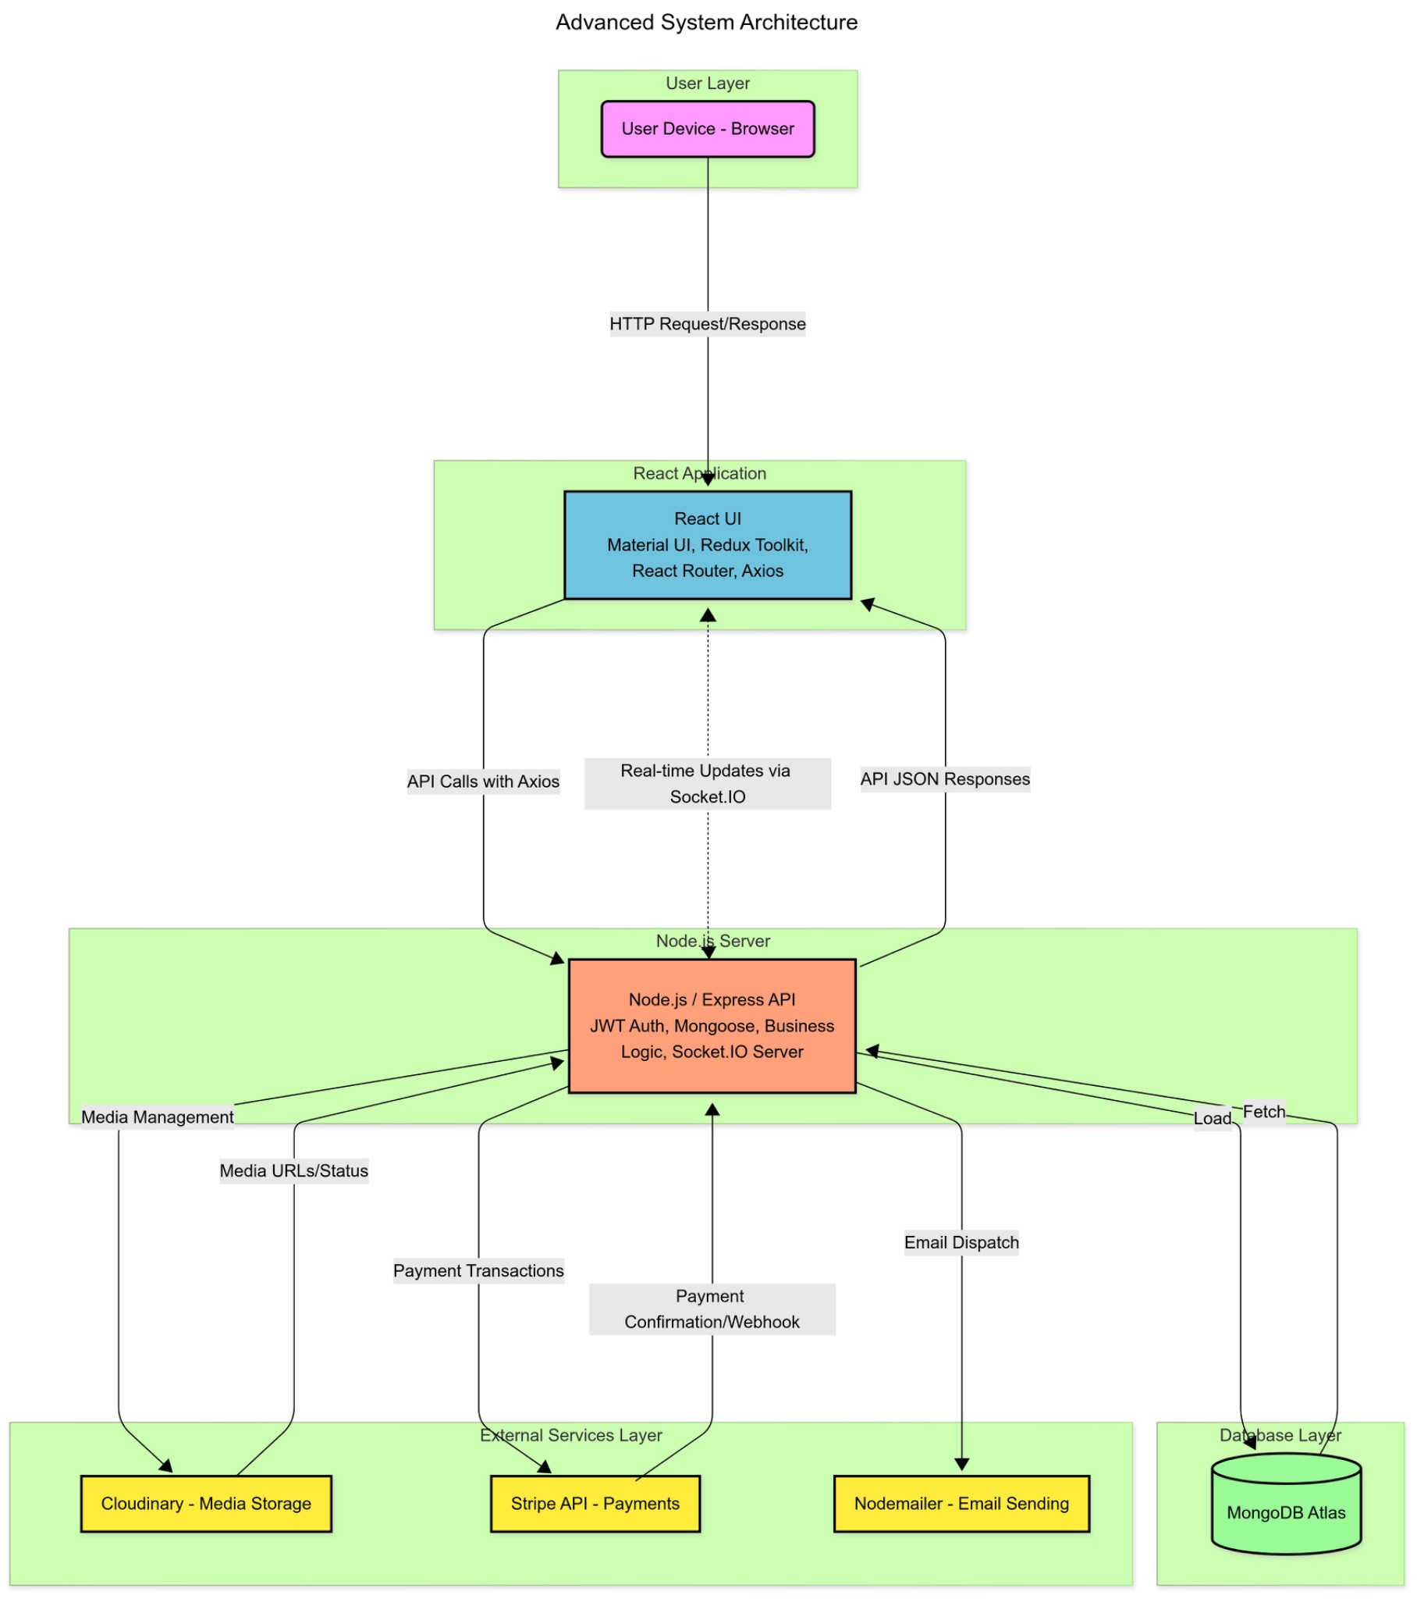

Table -1 : Technical Architecture

|  |  |  |  |
| --- | --- | --- | --- |
| **S.No** | **Component** | **Description** | **Technology** |
| 1 | **User Interface** | Frontend interface for students, instructors, and admins to interact with courses and dashboards. | HTML, CSS, JavaScript, React.js, Material UI |
| 2 | **Application Logic-1** | Handles course creation, content upload, and instructor module management. | React.js, Redux Toolkit |
| 3 | **Application Logic-2** | Manages student authentication, enrollment, payment validation, and JWT session handling. | Node.js, Express.js, JWT Authentication |
| 4 | **Application Logic-3** | Generates analytics and progress reports for both students and instructors (charts, stats). | Chart.js, React-Chartjs-2, Node.js |
| 5 | **Database** | Stores user accounts, course metadata, progress data, and transaction logs. | MongoDB Atlas |
| 6 | **Cloud Database** | Cloud-hosted NoSQL database for scalability and distributed storage. | MongoDB Atlas |
| 7 | **File Storage** | Stores uploaded course assets like PDFs, videos, and images securely. | Cloudinary Storage |
| 8 | **External API-1** | Handles transactional email notifications (password reset, payment receipts, etc.). | Nodemailer, SMTP |
| 9 | **External API-2** | Integrates with payment services and automation tools (payments, receipts, notifications). | Stripe API, Webhooks |
| 10 | **Machine Learning Model** | *(Optional/Future)* Personalized course recommendation system based on user behavior. | Python, Scikit-learn, TensorFlow |
| 11 | **Infrastructure** | Cloud-hosted deployment of backend services with containerization and secure scaling. | Docker, Kubernetes, IBM Cloud / DigitalOcean / AWS |

Table -2: Application Characteristics

|  |  |  |  |
| --- | --- | --- | --- |
| **S.No** | **Characteristics** | **Description** | **Technology Used** |
| 1 | **Open-Source Frameworks** | The platform uses open-source, community-backed frameworks for creating responsive UIs and robust backend services. | React.js / Node.js / Express.js / Chart.js / MongoDB |
| 2 | **Security Implementations** | Security is ensured through HTTPS, JWT-based authentication, SSL encryption, role-based access, and secure Stripe payment handling. | SSL, HTTPS, JWT Tokens, Stripe API, bcrypt hashing |
| 3 | **Scalable Architecture** | Designed using a microservices-friendly and modular 3-tier architecture (Presentation, Logic, Data Layer) for easy scaling and maintenance. | Node.js (Backend), React.js (Frontend), MongoDB (Database), Docker |
| 4 | **Availability** | Cloud deployment with distributed architecture, auto-scaling, and load balancers ensure 99.9% uptime and fault tolerance. | DigitalOcean / AWS / IBM Cloud, Docker, Kubernetes |
| 5 | **Performance** | Optimized for fast response times using caching, Content Delivery Network (CDN) for static files, and efficient MongoDB indexing. | Cloudflare (CDN), Redis (Caching), MongoDB Indexing |

# 4. PROJECT DESIGN

## 4.1 Problem Solution Fit

The **Problem–Solution Fit Canvas** allowed us to align our E-Learning Platform's core features with the evolving needs of modern learners, instructors, and administrators. Through continuous user feedback and industry research, we identified that traditional online learning tools often suffer from:

* Limited interactivity and personalization for students.
* Complex and rigid content management systems for instructors.
* Lack of real-time insights and progress tracking for administrators.
* Fragmented payment and certification workflows, which reduce the learning experience’s fluidity.

By carefully mapping out the user journey, pain points, and expectations of each stakeholder — students, instructors, and admins — we refined our solution to directly address these challenges.

Our platform enables:

* Instructors to create structured courses, upload multimedia content, and track student engagement — without requiring advanced technical knowledge.
* Students to learn at their own pace with progress tracking, course bookmarking, and instant certification on completion.
* Administrators to oversee content, manage roles, monitor system health, and ensure smooth payment and reporting workflows.

This approach ensured that our solution is not only technically robust but also **user-centered, scalable, and ready for real-world adoption** in educational environments ranging from small institutes to large online academies.

## 4.2 Proposed Solution

|  |  |  |
| --- | --- | --- |
| **S.No** | **Parameter** | **Description** |
| 1 | **Problem Statement** | Many learners and educators face difficulties accessing flexible, affordable, and interactive online education. Existing platforms often lack personalization, smooth content delivery, and intuitive course management — limiting both engagement and scalability. |
| 2 | **Idea / Solution Description** | The E-Learning Platform is a full-featured, user-friendly web application that empowers instructors to build and manage courses, track student progress, and automate certification — while offering learners a seamless and interactive digital classroom experience. |
| 3 | **Novelty / Uniqueness** | Unlike conventional learning platforms, this system combines real-time analytics, role-based dashboards, secure payments, and certificate generation — all built on an open-source MERN stack, allowing easy customization and cost-effective deployment. |
| 4 | **Social Impact / Customer Satisfaction** | The platform enhances accessibility to quality education for students, while empowering instructors and small institutions to deliver courses globally without large budgets or advanced technical skills — increasing both reach and satisfaction. |
| 5 | **Business Model (Revenue Model)** | The solution can adopt a **Freemium model** — basic access for free, with premium features like advanced analytics, priority support, and custom branding offered through monthly subscriptions. Enterprise packages and white-label options can also be offered. |
| 6 | **Scalability of the Solution** | The platform’s cloud-native, modular architecture supports smooth scaling for both traffic spikes and user growth. Leveraging containerization (Docker) and cloud databases allows efficient handling of large course libraries and concurrent student access. |

## 

## 4.3 Solution Architecture

The **EEG-Based Game Controlling System** is an innovative brain-computer interface **E-Learning Platform (MERN Stack)** is a dynamic online learning solution built using the MERN (MongoDB, Express.js, React.js, Node.js) stack. Its architecture is designed to effectively bridge the gap between educational needs and technology by providing a secure, interactive, and scalable platform for digital learning.

1. Finding the Best Tech Solution for Educational Challenges

E-Learning Platform (MERN Stack) addresses common challenges in online education, such as:

* The need for **intuitive course creation tools** for instructors
* **Secure handling** of student data and payment processing
* **Seamless integration** with third-party tools for enhanced functionality

The MERN stack was selected for its flexibility, performance, and robust ecosystem:

* **MongoDB** offers flexible document storage for courses, user progress, and certifications
* **Express.js** and **Node.js** efficiently handle backend logic and API services
* **React.js** provides a responsive, dynamic interface for both learners and instructors

2. Describing the Software Architecture to Stakeholders

E-Learning Platform (MERN Stack) follows a 3-tier architecture:

* **Presentation Layer (React.js)**: Handles all UI components including course dashboards and admin panels
* **Application Layer (Express.js + Node.js)**: Manages course logic, authentication, and payment processing
* **Data Layer (MongoDB)**: Stores course content, user data, and analytics

Additional platform features include:

* Real-time progress tracking and notifications
* Customizable learning paths and course branding
* Integrated analytics for performance monitoring

3. Defining Features, Development Phases, and Requirements

**Key Features:**

* Drag-and-drop course builder
* Multimedia content support (videos, PDFs, interactive quizzes)
* JWT authentication and Stripe payment integration
* Certification generation and tracking
* Discussion forums and live Q&A capabilities

**Development Phases:**

1. Phase 1 – Core Learning Platform UI (React.js)
2. Phase 2 – Backend Services & Database Architecture (Express/MongoDB)
3. Phase 3 – Authentication & Payment Integration
4. Phase 4 – Interactive Features (forums, notifications)
5. Phase 5 – Deployment & Performance Optimization

**Requirements:**

* Responsive design for all device types
* Role-based access (students, instructors, admins)
* High availability with scalable infrastructure

4. Providing Specifications for Managing and Delivering the Solution

E-Learning Platform (MERN Stack) implements industry best practices for software delivery:

* **Version Control**: Git/GitHub for team collaboration
* **CI/CD**: Automated testing and deployment pipelines
* **Containerization**: Docker for consistent environments
* **Cloud Deployment**: AWS or Vercel for global availability
* **Monitoring**: Performance tracking and error logging

# 5. PROJECT PLANNING & SCHEDULING

## 5.1 Project planning

## Product Backlog and Sprint Schedule for E-learning Platform

1. Agile Methodology Implementation

The platform follows **Scrum-based Agile development** to ensure iterative delivery of functional components:

* **Sprint Cycles**: 2-week sprints with prioritized backlogs
* **User Stories**: Epics broken into atomic tasks (e.g., "As a student, I want to track progress")
* **Story Points**: Fibonacci-based estimation (1-5 scale) reflecting complexity
* **Definition of Done**: Completion criteria include passing tests and stakeholder review

2. Technical Architecture Theory

**MERN Stack Selection Rationale**:

* **Component-Based UI (React)**: Enables reusable course components and real-time DOM updates
* **RESTful Services (Express/Node)**: Stateless API design supports horizontal scaling
* **Document Storage (MongoDB)**: Flexible schema accommodates evolving course structures
* **JWT Authentication**: Secure token-based sessions with role-based claims

**Andragogical Principles Applied**:

* Self-directed learning via progress tracking
* Social learning through discussion forums
* Microlearning support with modular content

**Assessment Design**:

* Formative: Embedded quizzes with immediate feedback
* Summative: Certification upon completion metrics
* Predictive: Analytics identify at-risk learners

3. Quality Assurance Framework

**Testing Pyramid Implementation**:

1. **Unit Tests**: Jest for React components, Mocha for API routes
2. **Integration Tests**: Supertest for API endpoints
3. **E2E Tests**: Cypress for critical user journeys

**Security Protocols**:

* CSRF protection for forms
* Payment data isolation via Stripe Elements
* Regular dependency audits using npm audit

## 

## Project Tracker, Velocity & Burndown Chart

|  |  |  |  |  |
| --- | --- | --- | --- | --- |
| **Sprint** | **Total Story Points** | **Duration** | **Sprint Start Date** | **Sprint End Date (Planned)** |
| Sprint-1 | 20 | 6 Days | 01 Apr 2025 | 06 Apr 2025 |
| Sprint-2 | 22 | 6 Days | 07 Apr 2025 | 12 Apr 2025 |
| Sprint-3 | 22 | 6 Days | 14 Apr 2025 | 19 Apr 2025 |
| Sprint-4 | 22 | 6 Days | 21 Apr 2025 | 26 Apr 2025 |

## Velocity Chart (Summary)

|  |  |
| --- | --- |
| **Sprint** | **Story Points Completed** |
| Sprint-1 | 20 |
| Sprint-2 | 19 |
| Sprint-3 | 17 |
| Sprint-4 | 22 |

Average Velocity=(20+19+17+22)/4​=19.5 Story Points per Sprint

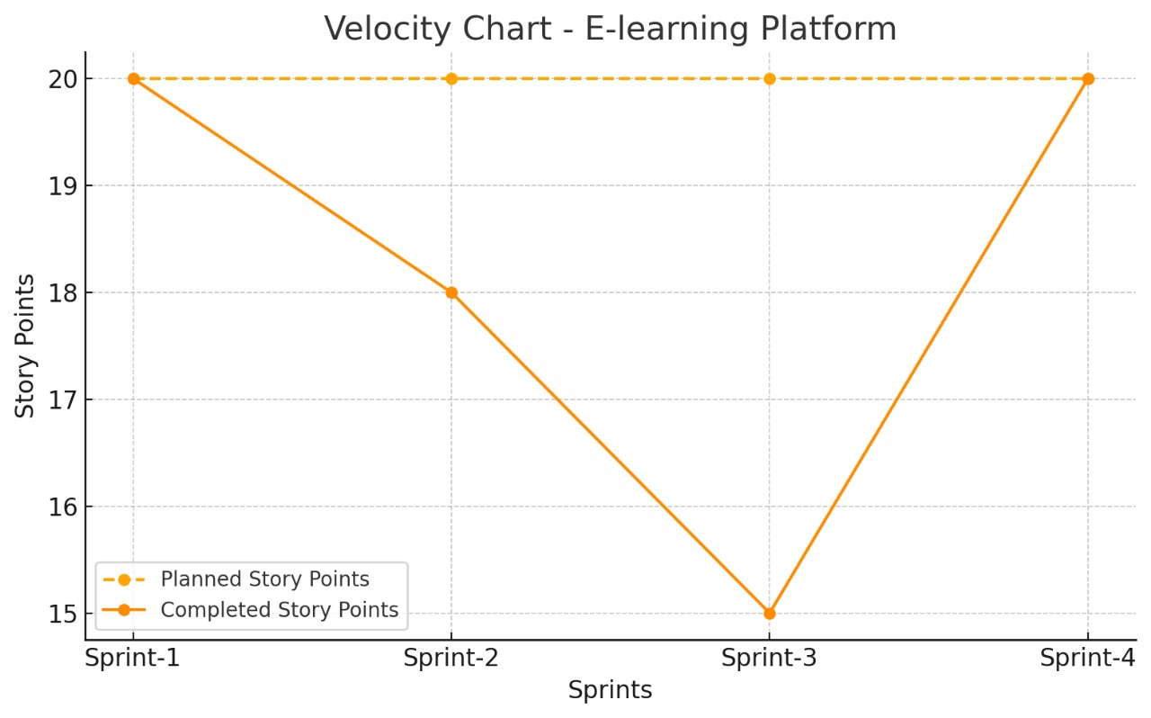

## Burndown Chart Data

|  |  |  |
| --- | --- | --- |
| **Day** | **Planned Remaining Points** | **Actual Remaining Points** |
| **Day 1** | **20** | **20** |
| **Day 2** | **16** | **16** |
| **Day 3** | **12** | **13** |
| **Day 4** | **8** | **9** |
| **Day 5** | **4** | **5** |
| **Day 6** | **0** | **0** |

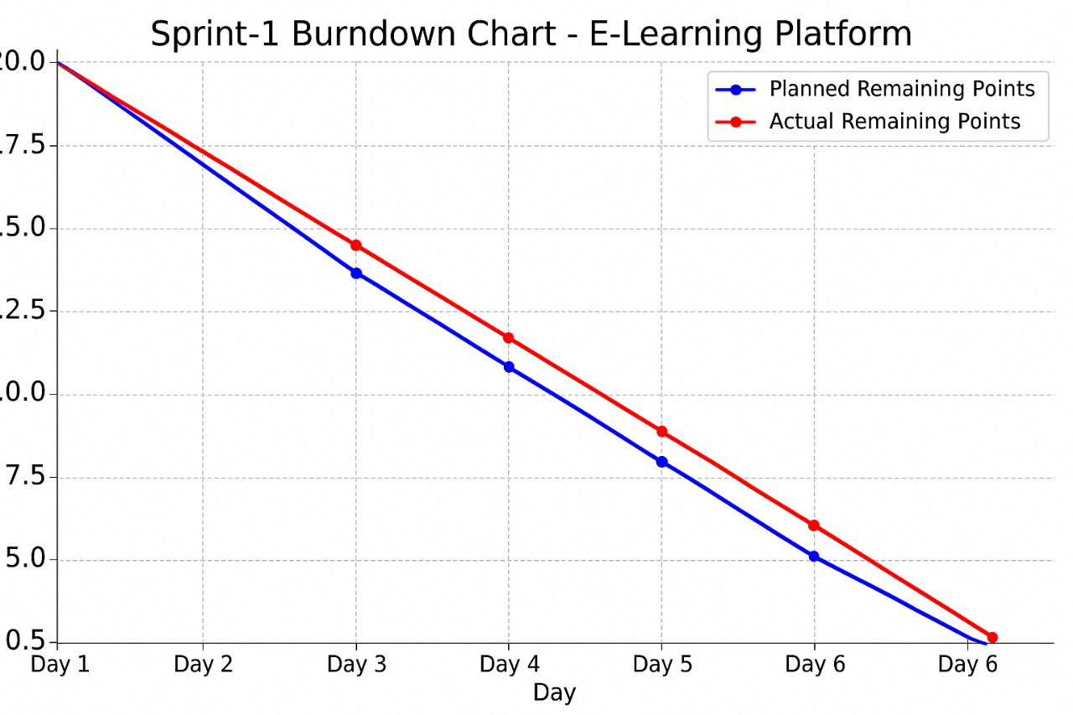

## Agile Sprint Breakdown for E-learning Platform

## Epic: User Registration & Authentication

|  |  |  |  |
| --- | --- | --- | --- |
| **Task** | **Story** | **Story Points** | **Complexity** |
| Design registration page (email/password) | USN-1 | 2 | Easy |
| Implement user registration logic | USN-2 | 3 | Medium |
| Implement JWT-based Login & Session Handling | USN-3 | 2 | Medium |
| Develop basic course catalog page (frontend) | USN-4 | 3 | Medium |

**Total Story Points (Sprint 1): 10**

Sprint 2 (5 Days)

**Epic: Form Input Features & Security**

|  |  |  |  |
| --- | --- | --- | --- |
| **Task** | **Story** | **Story Points** | **Complexity** |
| **Create Course Builder drag & drop (Instructor)** | **USN-5** | **4** | **High** |
| **Implement content management for PDFs, videos, quizzes** | **USN-6** | **4** | **High** |
| **Admin: User Role Management Module** | **USN-7** | **2** | **Medium** |
| **Admin: System Health & Monitoring Dashboard** | **USN-8** | **2** | **Medium** |

**Total Story Points (Sprint 2): 12**

**Velocity Calculation**

Total Story Points = 10 (Sprint 1) + 12 (Sprint 2) = 22

No. of Sprints = 2

Velocity = Total Story Points / Number of Sprints

Velocity = 22 / 2 = 11 Story Points per Sprint

**Team’s velocity is 11 Story Points per Sprint**

# 6. RESULTS

# 6.1 OUTPUT SCREENSHOTS

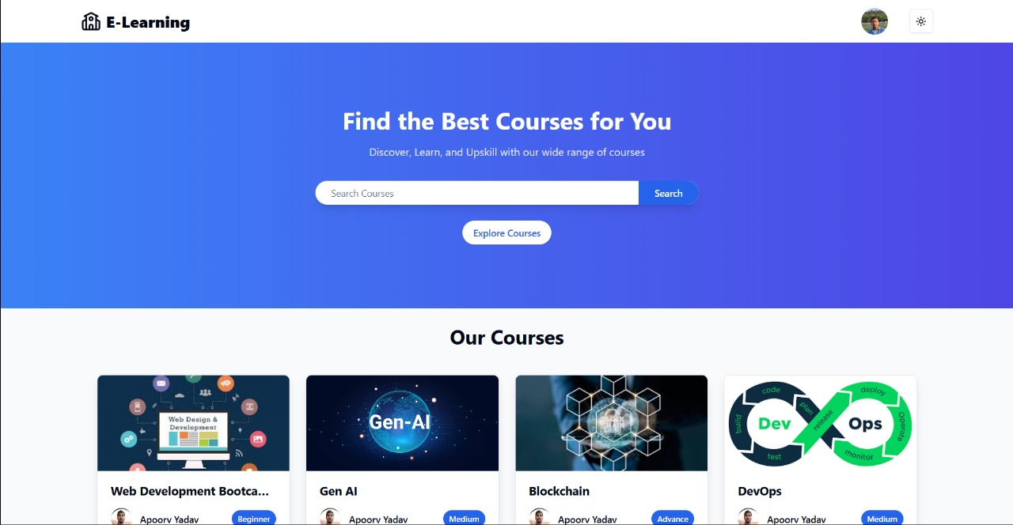

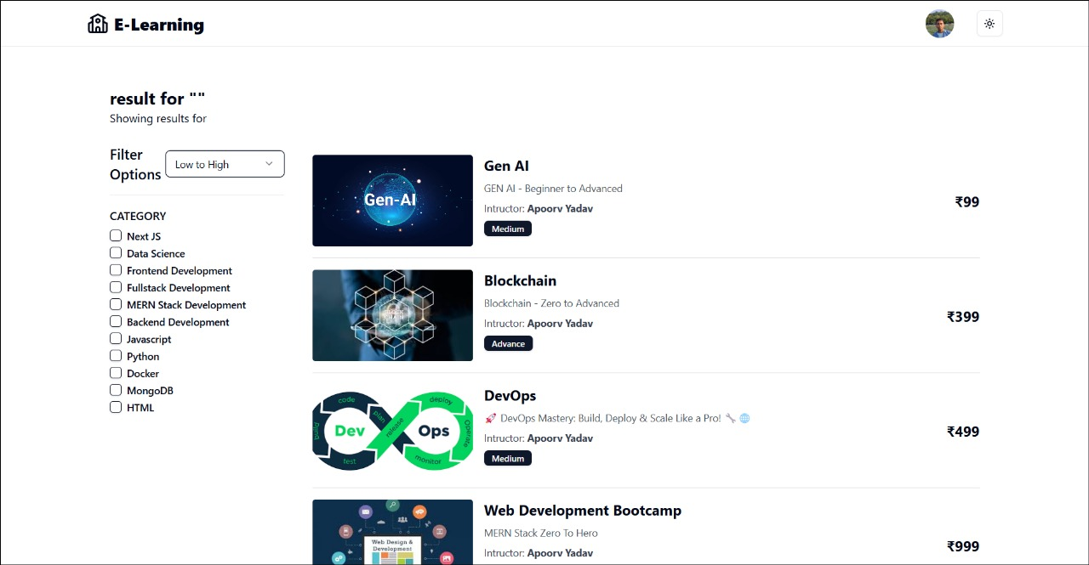

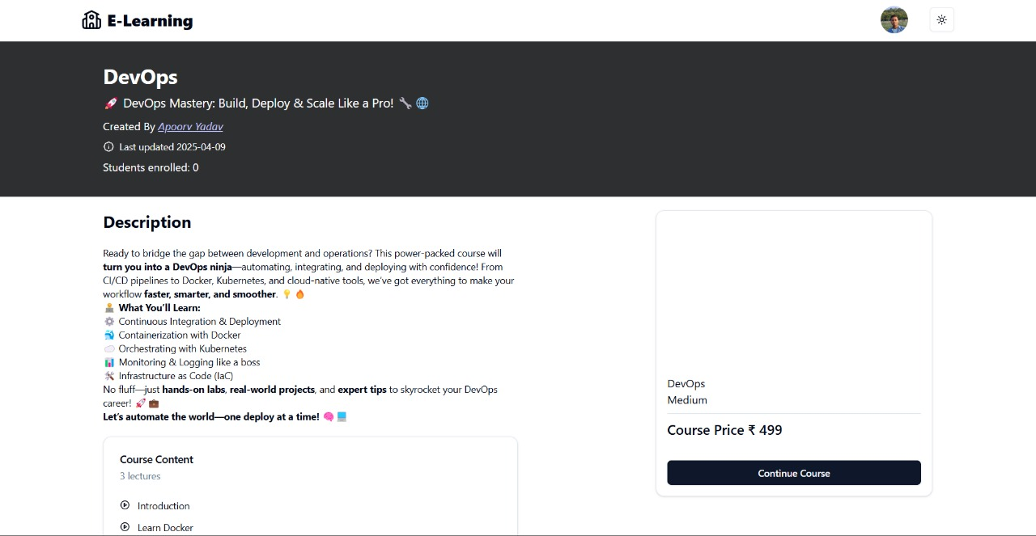

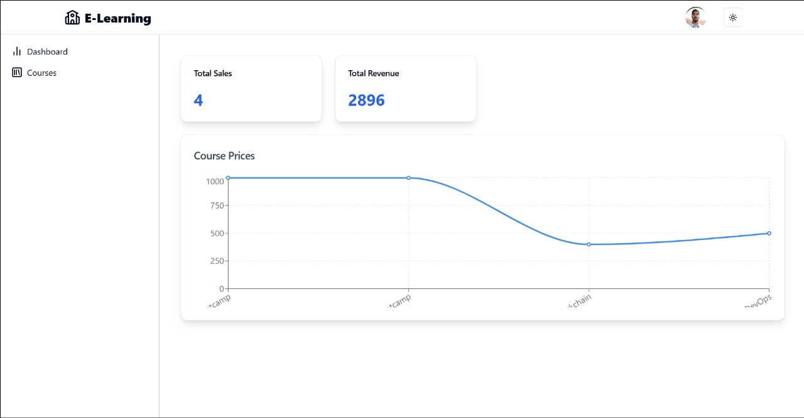

# 7. ADVANTAGES

# 7.1 Advantages of E-learning Platform

**I. Feature-Rich for All Roles**

* Modular Course Builder makes content creation simple for instructors.
* Progress Tracking & Certification motivates learners and boosts engagement.
* Role-Based Access ensures secure and organized user control (admin, instructor, student).

**II. Modern Tech Stack**

* MERN Stack offers fast development, high performance, and active community support.
* Real-Time Interactions enabled by Socket.IO for features like forums and live updates.
* Cloud Storage (Cloudinary) optimizes media handling and performance**.**

**III. Monetization Support**

* Stripe Integration allows secure payments and revenue tracking.
* Revenue Dashboard helps instructors manage income effectively**.**

**IV. Secure & Scalable**

* JWT Authentication ensures secure user sessions.
* MongoDB Atlas provides scalable and cloud-hosted database access**.**

**V. Developer-Friendly**

* Clean React + Redux frontend structure.
* RESTful APIs and reusable components improve maintainability.
* Testing with Jest ensures reliability during development**.**

# 7.2 Disadvantages of E-learning Platform

**I. Technical Overhead**

* Requires knowledge of multiple frameworks (React, Node, MongoDB, Express).
* Initial setup is more complex due to multi-part configuration (frontend/backend + environment vars).

**II. External Dependencies**

* Relies on third-party services like Stripe and Cloudinary, which may have limits or fees.
* Hosting costs may increase with scale (e.g., Cloudinary, MongoDB Atlas tiers).

**III. Performance Concerns**

* Real-time features and high video traffic may strain performance on lower-tier hosting.
* Needs proper load balancing and optimization for production deployment.

**IV. Limited Offline Access**

* Like most web-based apps, this platform doesn’t support offline learning by default.
* Video and content access depends on internet connectivity**.**

**V. Maintenance & Testing**

* While Jest is used, full testing coverage might require extra time and effort.
* Frequent library updates in the MERN ecosystem can cause compatibility issues.

# 8. CONCLUSION

The E-Learning Platform developed using the MERN stack presents a powerful, scalable, and modern solution tailored for the evolving demands of digital education. By combining a responsive frontend (React) with a robust backend (Node.js and Express) and a flexible NoSQL database (MongoDB), the platform offers an engaging user experience for students, instructors, and administrators alike.

Key features such as progress tracking, certification generation, real-time discussions, and secure payments make it a comprehensive system capable of managing end-to-end learning workflows. Its modular course builder, analytics tools, and user management capabilities empower instructors and admins with the control they need to deliver and oversee effective learning experiences.

While the platform introduces some technical complexity and operational dependencies, its structure makes it a strong foundation for future innovation. With the right enhancements, it can evolve into a full-fledged, enterprise-level LMS that competes with top e-learning solutions on the market.

# 9. FUTURE SCOPE

* **Mobile App Support** using React Native for seamless learning on smartphones.
* **AI-powered recommendations** for personalized course suggestions.
* **Gamification features** like badges, leaderboards, and challenges to boost engagement.
* **Multilingual Support** to cater to a global audience.
* **Video Streaming Optimization** with adaptive bitrate streaming.
* **Integration with LMS Tools** like Moodle or SCORM packages.
* **Advanced Analytics** with dashboards powered by charting libraries or AI insights.
* **Offline Learning Mode** with downloadable lessons and caching.
* **Role-based notifications** using push/email for assignments, updates, and payments.
* **Admin Panel Enhancements** like drag-and-drop role access or plugin management.

# 10. APPENDIX

# 10.1 GitHub & Project Demo Link

<https://github.com/akarsh-debug/E-Learning-Platform>

Project Demo Link:

https://drive.google.com/file/d/1ihu2ZLT9wRR-_s2vNNQMW6P22mkupk5k/view